Poland Community Baseball Association,
Inc.

Poland Community Baseball Association, Incorporated
Poland, Ohio 44514

Dear Friend of Poland Baseball:
The Poland Community Baseball Association, Inc. is preparing for the 2024 baseball season. It is the organization’s 74th season of serving the children of Poland by providing quality baseball/Softball for boys and girls between the ages of 4 and 19. 2023 was exciting with a total of over 450 Players in participation. Thank you so very much to Last Year’s Sponsors for YOUR SUPPORT!

We need your help! The success of the league is largely dependent on the financial help of businesses and organizations that generously support teams as sponsors and we sincerely thank our prior sponsors and offer appreciation for their support. If you are interested in participating as a sponsor, please fill out the enclosed form and return it with your check payable to the Poland Community Baseball Association (or PCBA) and mail it to: PCBA c/o Pat Carney
PO Box 5215
POLAND, OHIO 44514
The PCBA is offering 4 options for the 2024 season.
Option 1 provides for single or multi team sponsorship and includes a multi team discount. Option 2 will actually save money for sponsors who normally support us throughout the year. Option 3 presents an opportunity to support our leagues and gain exposure via our field fence signs. New this year we are offering limited Field sponshorships.There will only be 1 filed sponsor offered per field. The details for all of the options are as follows:

- PCBA Team Sponsor--$375.00 or Two Team Sponsorships for $650.00
2. PCBA SPONSOR--$500.00 per year includes the following:
*Team Sponsorship
*3’X8’ fence sign
*Hole Sponsor for the Matt Hardy Memorial Scholarship Golf Outing
*Listing of your LOGO on our Website Sponsor Page.

3. PCBA Fence Sign Sponsor $200 (call or email for details)-- your Corporate Colors with name and logo on a 3'x8' sign placed along the fence in the outfield

4. PCBA Field SPONSOR $1500 for 1 year you will receive everything listed in the PCBA SPONSOR (Option 2) plus a Large banner placed over Home plate fence with your
Company name and logo. There will only be 1 field sponsor allowed per field.
** Please note that your response is requested by the 10th of February.
This will help to better ensure for your request to Sponsor and to ensure your team and color preferences are accommodated. It will also aid in our timely preparation of team uniforms and league organization.

Please call Pat with any questions at: 330-540-2923 or email at PCBAinfo@yahoo.com
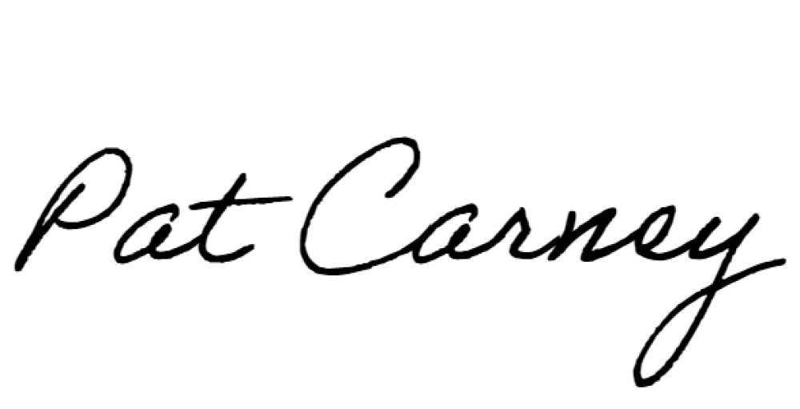
Sincerely,
Pat Carney
President
• 310 Sheridan Road • Poland, Ohio 44514 • (330) 757-9007

